**The Wrath(s) of God Revealed Through the Word**

Romans 1:18, Ephesians 5:6, John 3:36, Romans 5:9

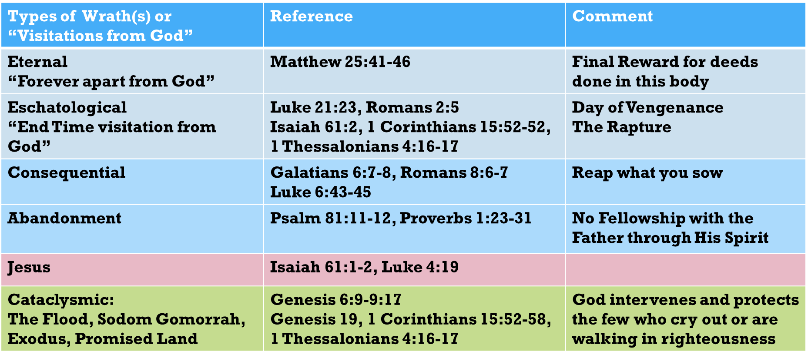

**Facts to Know**

* There are 2 kingdoms in existence; Kingdom of God and the Kingdom of Satan: **Mark 3: 24-26, Matthew 12:22-32**
* One Kingdom has come to kill and the other to bring life, **John 10:10**
* All people are serving one Kingdom or the other, **Romans 6:12-16**
* Your words and actions show which Kingdom you are serving, **James 2:18, Proverbs 18:21, Proverbs 12:6**
* He who sows righteousness brings life, **Galatians 6:7-8, Romans 8:6-7**
* He who sows wickedness reaps death, **Galatians 6:7-8, Romans 8:6-7**
* Every person will give an account of their words and actions: **Matthew 12:36, Matthew 16:27, Romans 14:12**
* Jesus said He did not come to condemn, but to bring salvation – to make our lives safe and sound, **John 3:17**
* Jesus said as many as receive Him to them He gives power to walk as His followers**, John 1:11-12**
* Jesus said there will be one to judge us when we stand before God and that will be the Word of God. The Words He spoke to us, **John 12:47-48**

**Where Do You Get Your Information**

**Reaffirm Your Source of Truth – Proverbs 14:30, 17:22**

* **The Word**
  + 2 Timothy 3:16-17
  + Romans 15:4, 1 Corinthians 10:11
  + Psalm 119:105
  + Matthew 5:17-18
  + Numbers 23:19
  + Hebrews 13:8
  + Mark 13:31 (3500 years+)

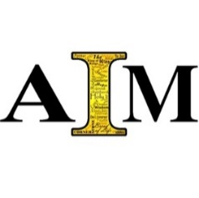

**Know the Character of God**

* + Numbers 23:19 (does not lie)
  + 1 John 1:5 (no darkness)
  + 1 Corinthians 14:33 (no confusion)
  + Lamentations 3:22-23, 1 John 1:9 (merciful)
  + James 1:13 (not tempted by evil)
  + Ezekiel 18:23, 33:11 (no pleasure in death of the wicked)
  + Ezekiel 22:30 (a man to stand in the gap)
  + Mark 13:31, Isaiah 55:10-11 (not return void)
  + John 8:12 (light of the world)
  + John 14:9 (you’ve seen the Father)
  + Hebrews 13:8 (same yesterday…)
  + 2 Timothy 2:15 (rightly divide the word ...)
  + 2 Corinthians 13:1 (2 or more witnesses)
  + Psalm 105:15 (Protects His people)
  + John 3:17, 12:46-47 (No condemnation)
  + Matthew 12:22-32, Mark 3:24-26 (kingdom divided)
  + Acts 10:34 (No respecter of persons)

**What Does the Word Say?**

* Proverbs 14:30
* Isaiah 26:3
* John 3:17 / Psalm 91 / Psalm 107:20
* Acts 3:19
* Hebrews 9:27

**Understand the PATH of Disease in Man**

1 Peter 2:24, Revelation 19:13, Proverbs 14:30, Isaiah 26:3, Proverbs 4:20-27, 12:6, 17:22, John 8:31-32

**Life Words based on God’s Word**

Psalm 118:17

I will live and not die…

Phil 4:13

I can do all things through Christ….

Phil 4:19

He provides ALL my needs…

**Death words based on what**

**you see, hear, taste, touch/feel,**

**smell**

I am Sick

I am Tired

I am Confused

I am Scared