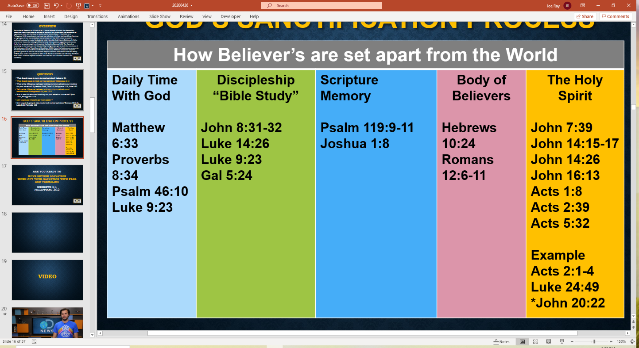

**Working out your salvation**

Hebrews 6:1

Philippians 2:12

1 Corinthians 9:27

Galatians 5:24

Ephesians 4:27

Romans 13:14

**God’s Working out Your Salvation**

**and Sanctification Process “IN ACTION”**

Daily Actions of Working Out Your Salvation

**Jesus’ Example**

John 1:1, 14

Matthew 3:13-17

Luke 4:1-13

**Walking in Righteousness**

Isaiah 32:17

Romans 14:17

John 8:12

Psalm 119:165

Proverbs 4:18, 20-23

**Peace and Confidence**

Proverbs 3:26

Isaiah 26:3

**Calm & Undisturbed Mind**

Proverbs 14:30

Proverbs 17:22

**A Healthy Body**

Genesis 6:3

John 15:11

**The Sanctification Process**

Produces

Leads to

**The Word**

John 17:17

Ephesians 5:26

Psalm 119:105, 130

Hebrews 4:12

2 Timothy 3:16-17

**Holy Spirit**

John 14:16-17, 26

John 16:13-15

Acts 1:8

The writer of Hebrews In 6:1 tells us to “…move beyond salvation, the elementary teachings about Christ and go forward to maturity, not laying again the foundation of repentance from acts that lead to death, and of faith in God,…” Paul tells us in Philippians 2:12, to continue to work out our salvation with fear and trembling. He gives us a glimpse of how he worked out his salvation in 1 Corinthians 9:27, where he said he buffeted his body, he made his body do what it should. And, then in Galatians 5:24, he tells us that those who belong to Christ crucify their passions, appetites and desires. He further gives us insight how to control the flesh in Romans 8:13, "For if you live according to the flesh, you will die; but if by the Spirit you put to death the misdeeds of the body, you will live.” And, then in Revelation 12:11, it says that believers overcome by the blood of the lamb and the word of their testimony. All these scriptures begin to paint the picture on how we are to move beyond salvation and work it out to the Glory of God. Jesus said it very plainly in John 14:21 that if we love Him we will keep His Word. That is how we move beyond salvation and work out our salvation with fear and trembling.

**Back to the Basics:**

**Move Beyond Salvation and Work out Your Salvation with Fear and Trembling!**