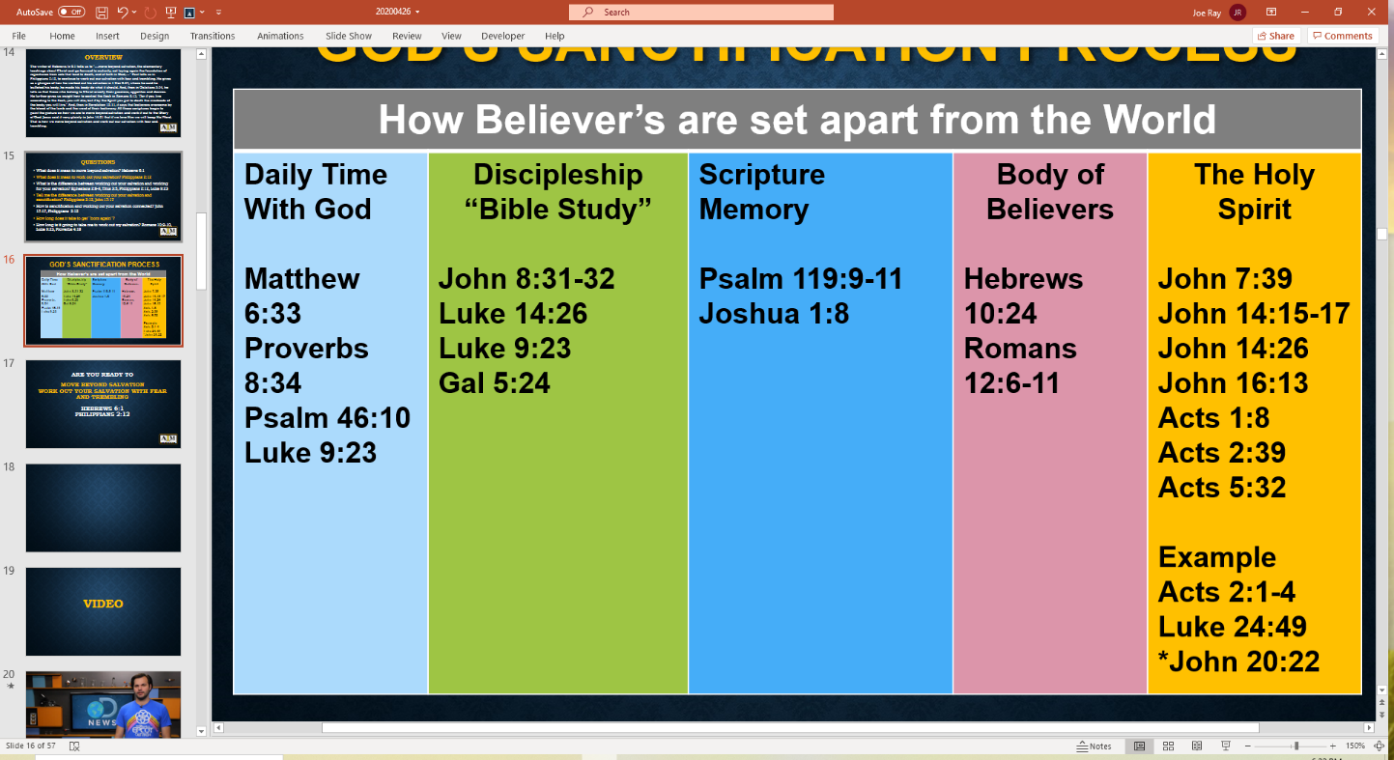

**WARNING**: What could happen if I choose not to work out my salvation? Luke 12:8-48, Matt 25:1-30, Heb 6:7-8, Rom 13:5, Heb 10:39, 2 Peter 2:20, 2 Thess 2:3, Heb 3:12-18, John 15:5-8

**God’s Working out Your Salvation**

**and Sanctification Process “IN ACTION”**

**Walking in Righteousness**

Isaiah 32:17, Rom 4:17

John 8:12, Psalm 119:165

Prov 4:20-23

**Peace and Confidence**

Prov 3:26, Prov 4:18

Isaiah 26:3

**Calm & Undisturbed Mind**

Prov 14:30, Prov 17:22

**A Healthy Body**

Gen 6:3

John 15:11, 16:33

**Eternity**

Matthew 25:1-13, 14-30

**Receive**

**Salvation**

John 3:16

Rom 10:9-10

**Seek/Do the Word**

John 17:17

Eph 5:26

Psalm 119:105, 130

Hebrews 4:12

2 Timothy 3:16-17

Working Out Your Salvation Leads to Life on Earth and to Eternity with the Father.

**The Process God Established to Work Out Your Salvation**

The writer of Hebrews, in 6:1 tells us to move beyond salvation, the elementary teachings about Christ and go forward to maturity. Paul tells us in Philippians 2:12, to continue to work out our salvation with fear and trembling. He gives us a glimpse of how he worked out his salvation, in Romans 12:2 he tells us to renew our minds with the Word of God. In 1 Cor 9:27, he said he disciplines his body. And, then in Galatians 5:24, he tells us that those who say their following the Word/Christ must crucify their passions, appetites, and desires. He further gives us insight on how to control the flesh in Romans 8:13, "For if you live according to the flesh, you will die; but if by the Spirit you put to death the misdeeds of the body, you will live.” And, then in Romans 10:6-8, he tells us that the answer is in our mouth. This is confirmed in Revelation 12:11, where it says that believers conquered the devil by the blood of the lamb and by the word of their testimony. All these scriptures begin to paint the picture on how we are to move beyond salvation and work it out to the Glory of God. Jesus said it very plainly in John 14:21, that if we love Him we will keep His Word. That is how we move beyond salvation and work out our salvation with fear and trembling.

How Do You Work “IT” Out?

Daily Actions of Working Out Your Salvation

**This Process is**

**Demonstrated in**

**Jesus Life**

John 1:1, 14

Matt 3:13-17

Luke 4:1-13

**Receive and Be Led by the Holy Spirit**

John 14:16-17, 26

John 16:13-15

Acts 1:8

Rom 8:14

**Work IT Out** Heb 6:1

Phil 2:12

1 Cor 9:27

Gal 5:24

Eph 4:27

Rom 13:14

**After Being Born Again –**

**You Are Called to Work Out Your Salvation**

**Back to the Basics:**

**Move Beyond Salvation and Work out Your Salvation with Fear and Trembling!**